**TEST CASE 1**

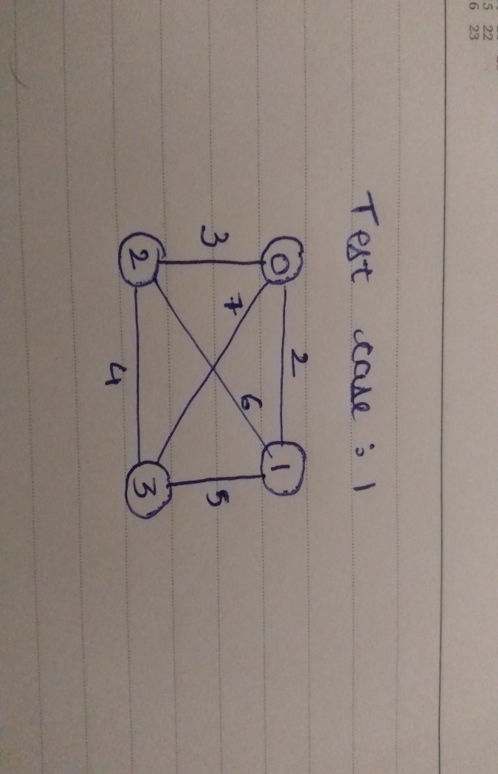

**OUTPUT**

vertex covers are:

[0, 2, 3]

[1, 2, 3]

[0, 1, 3]

[0, 1, 2]

Length of Minimum vertex cover for the given city is: 3

Minimum vertex cover is: [0, 2, 3] [1, 2, 3] [0, 1, 3] [0, 1, 2]

**TEST CASE 2**

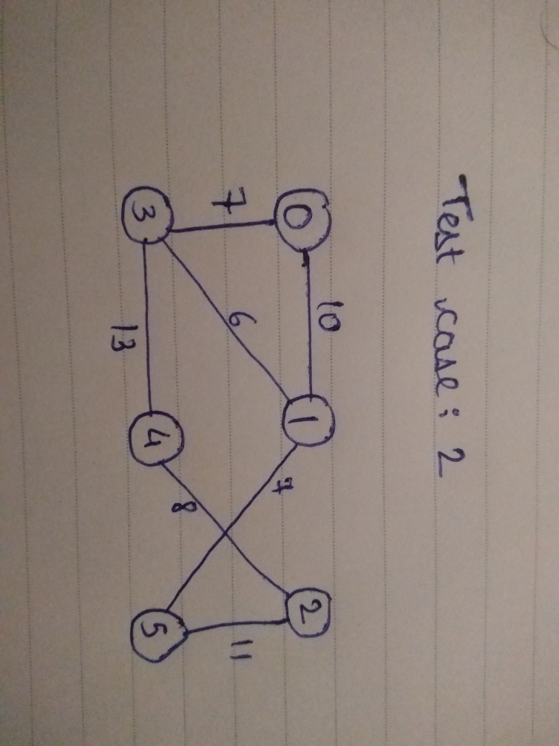

**OUTPUT**

vertex covers are:

[0, 1, 4, 5]

[0, 1, 2, 3]

[1, 2, 3]

[1, 3, 4, 5]

[0, 1, 2, 4, 5]

[1, 2, 3, 4]

[0, 3, 4, 5]

[0, 2, 3, 5]

[0, 1, 2, 3, 4]

[0, 2, 3, 4, 5]

Length of Minimum vertex cover for the given city is: 3

Minimum vertex cover is: [1, 2, 3]

**TEST CASE 3**

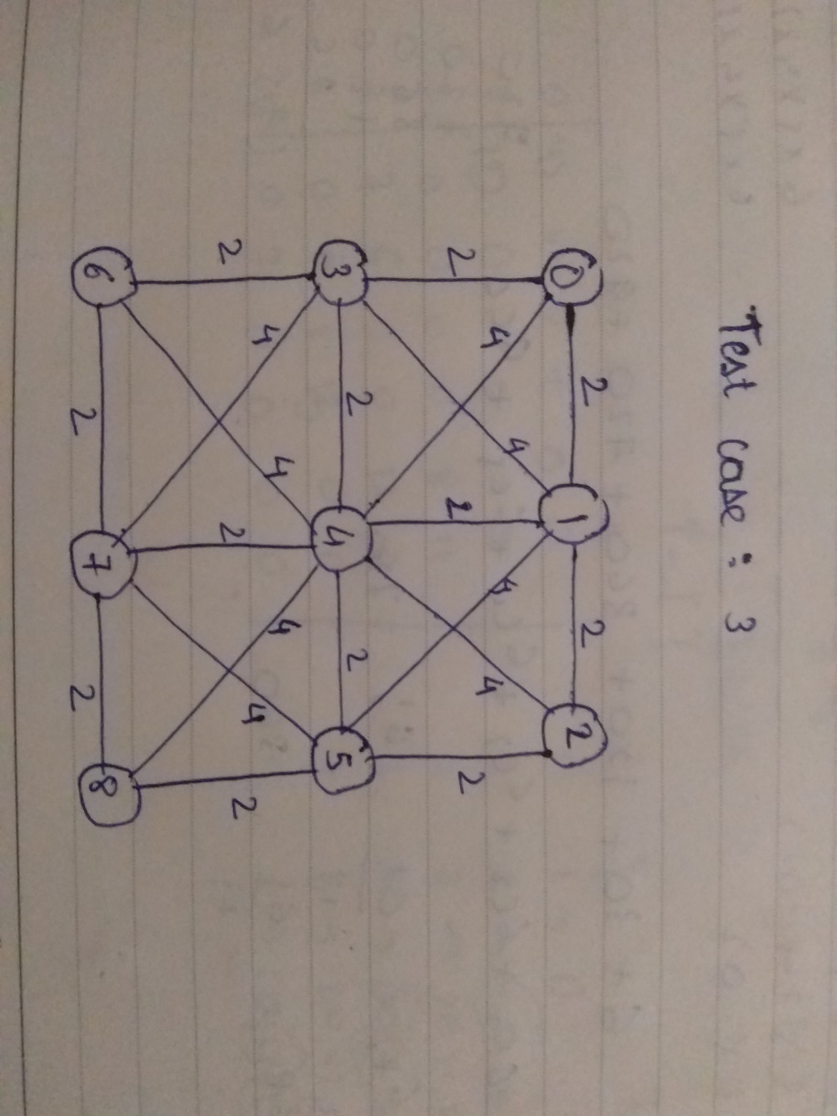

**OUTPUT**

vertex covers are:

[1, 2, 3, 4, 5, 7, 8]

[0, 1, 2, 3, 5, 6, 7, 8]

[0, 2, 3, 4, 5, 6, 7, 8]

[1, 2, 3, 4, 5, 6, 8]

[0, 1, 2, 3, 4, 5, 7, 8]

[0, 1, 2, 3, 4, 7, 8]

[0, 1, 2, 3, 4, 5, 7]

[0, 1, 2, 4, 5, 6, 7]

[1, 3, 4, 5, 7]

[1, 2, 3, 4, 5, 6, 7, 8]

[0, 1, 2, 3, 4, 6, 7, 8]

[1, 3, 4, 5, 6, 8]

[0, 1, 2, 3, 4, 5, 6, 7]

[0, 1, 3, 4, 5, 6, 8]

[0, 1, 4, 5, 6, 7, 8]

[0, 1, 3, 4, 5, 7, 8]

Length of Minimum vertex cover for the given city is: 5

Minimum vertex cover is: [1, 3, 4, 5, 7]